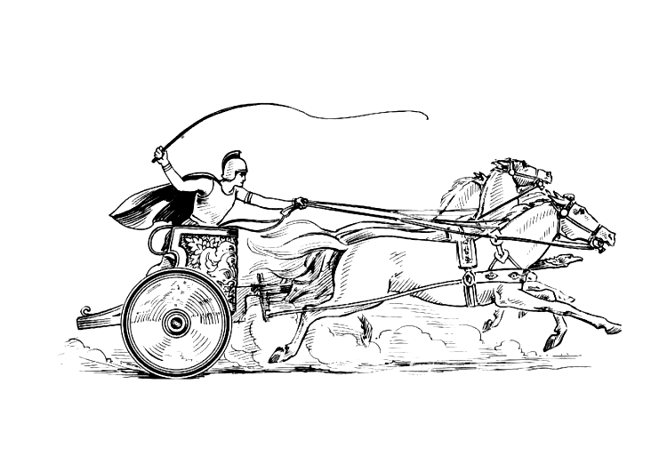Manduessedum - Mancetter Village (Place of War Chariots)
Mancetter Parish Council
Serving the People of Mancetter and Ridge Lane

You are invited to the Parish Council Meeting
to be held in the Schoolroom of St Peter’s Church Mancetter
on Tuesday 28th January 2025 at 7pm.

AGENDA

- Welcome, Apologies and update on Parish Councillor Vacancy.

- Chairman’s request that anyone recording the meeting make themselves known, to allow
openness and recognise practicalities. An audio recording of the meeting will be
made by the Council, and will be deleted upon production of the draft minutes.

- Declared notice of interest by Councillors concerning agenda items.

- Public Question time of up to 15 Minutes for Members of the Public to raise issues.

- Police, County and Borough Councillor feedback.

- Minutes of the last meeting.

To formally accept the draft minutes of the Parish Council Meeting held on 26th November 2024.

- To note the development of devolution plans and the impact for Warwickshire.
- To consider options for a review of the Mancetter Parish Neighbourhood Plan.

- Finance.
- Signing of all payments since the last meeting in accordance with Standing Orders, Financial Regulations and the Bank Mandate.

- To review the current allotment rents, and authorise the Chairman to collect payments on behalf of the Parish Council.

- To note the recent publication of the Good Councillors Finance Guide 2025 and pending changes to the future audit framework.

- Due to the need for disclosure of personal information, a publicly exempt discussion into staffing requirements will take place. The Council will then determine a revision in Clerk hours from February 2025 and confirm budget implications.
- To review the current financial position of the council and approve the finalised budget for the financial year April 2025 – March 2026.

- To analyse precept options and determine the Mancetter Parish Council Precept Request for the financial year April 2025 – March 2026.

- Correspondence, Consultations and Meetings involving the
Parish Council (Initials denote speaker)

- To note email correspondence received in Appendix one and update on any matters arising.
- To approve the list of Parish Council meeting dates for the new financial year.
- Ridge Lane recreation ground play area. JT
- Dog fouling signage and leaflet campaign. EH
- Town and Parish Council Reference Group. SH
- Artwork for Mancetter Village signs. EH

- Planning Matters and New Applications since the previous meeting.

- Update on Approved and Pending Applications

- PAP/2023/0324 – Outline Access application for the construction of three dwellings to the rear of the White Hart Inn Ridge Lane. Pending.

- PAP/2024/0209 – Brooklands Nuneaton Road Mancetter - Proposed detached double garage, timber shed with new boundary wall with altered access gates and tarmac access area. Pending.

- PAP/2024/0113 – Coachman’s Cottage Purley Chase Lane – proposed new dwelling. Pending.

- PAP/2024/0492 - Railway Cottage Quarry Lane Mancetter - For listed building consent to replace the back door. Granted.

- PAP/2024/0526 – Ardenhurst Nuneaton Road Mancetter –

Remodelling of property increasing ridge height incorporating loft conversion with dormer. Materials change, alterations to front elevation, including alterations to front elevation dormer. Proposed double garage to front of property. Rear single storey extensions. Pending.

- PAP/2024/0154 – Greenacres Nuneaton Road –

Change of use of land to extend the extent of land approved for vehicle retail sales [application referenced: PAP/2019/0489] and the erection of a single storey car sales building. Pending.

- PAP/2024/0160 – Greenacres Nuneaton Road –
A new agricultural style building to accommodate an area for preparation of vehicles as well as storage for maintenance equipment and vehicles. Pending.

- PAP/ 2024/0465 – 32 The Spinney Mancetter –

Work to trees protected by a Tree Preservation Order including removal of 7 of the 24 trees on site. Granted.

- County Council Minerals Application NWB/24CM013 Mancetter Quarry, Quarry Lane Mancetter.

Variation of condition 2 cessation of operations and restoration date of NWB/19CM009 and variation of condition 43 of application NWB/14CM034 Pending.

- New Planning Applications

- PAP/2024/0186 - Kirby Glebe Farm Atherstone Road Hartshill –

Change of use to land 150 metres south of Kirby Glebe to accommodate 4 Traveller pitches.

- PAP/2024/0588 – Crown Stables Nuneaton Road -

Prior approval for proposed conversion of agricultural barn into 1 bungalow.

- PAP/2024/0590 – Crown Stables Nuneaton Road –

Proposed Custom Build conversion of a former horse stables into 2 no 2-bedroom bungalows.

- Date of next meeting-
Tuesday 25th March 2025
7PM Schoolroom St Peter’s Church Mancetter.
Signed 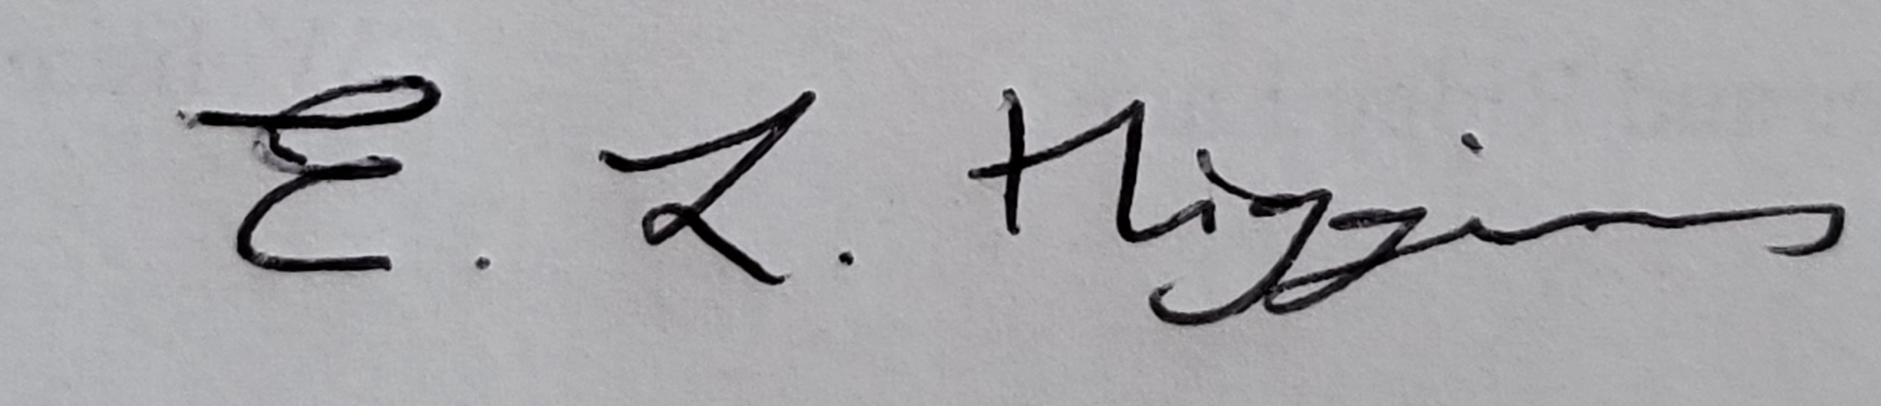
Date 23rd January 2025.

Elane Higgins
Parish Clerk Mancetter Memorial Hall Old Farm Road Mancetter CV9 1QN Tel: 01827 722552 Email: parishclerk@mancetterparishcouncil.gov.uk
Website: www.mancetterparishcouncil.gov.uk
Manduessedum - Mancetter Village (Place of War Chariots)
Mancetter Parish Council Serving the People of Mancetter and Ridge Lane

